## Creating Variations of your Sign

Creating variations for your custom sign is made very simple using the Sign Editor Palette in RapidPlan.

In RapidPlan you can quickly edit text in signs. Just double-click on any text object that’s part of a group or sign to edit it in-place.

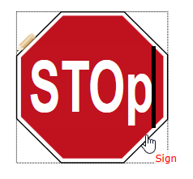

Double_click_to_edit_sign_text